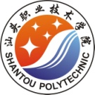



**汕头职业技术学院**

**高等职业教育质量年度报告**

**（2018）**

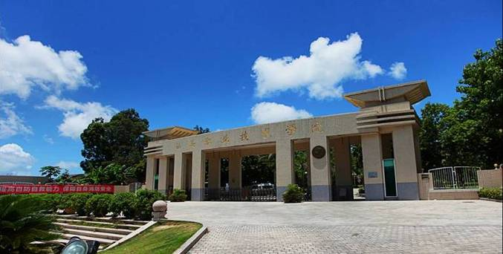

**广东·汕头**

**二〇一七年十二月**

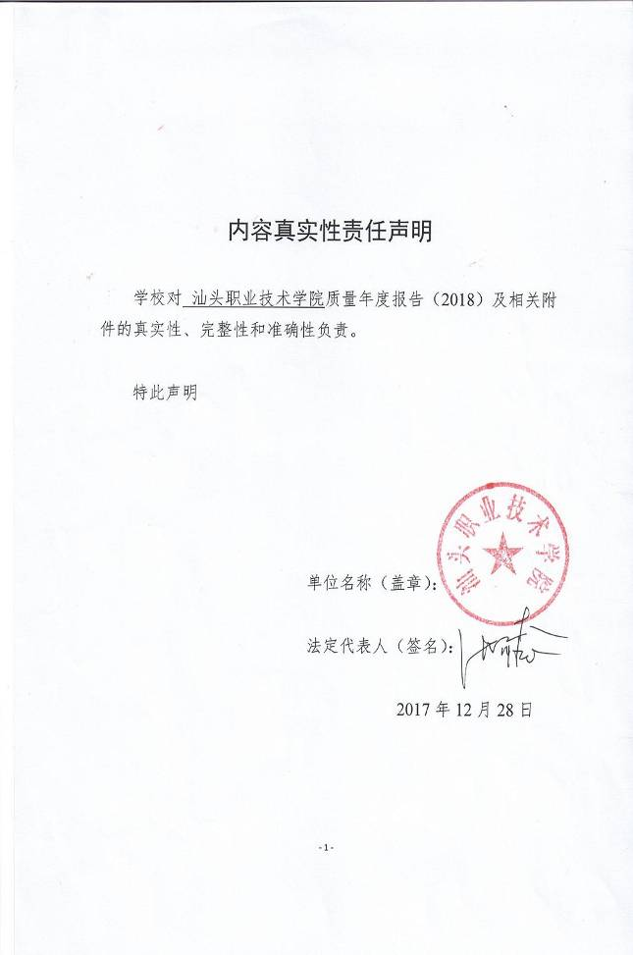

11

**目 录**

**一、学院基本情况** ⬝⬝⬝⬝⬝⬝⬝⬝⬝⬝⬝⬝⬝⬝⬝⬝⬝⬝⬝⬝⬝⬝⬝⬝⬝⬝⬝⬝⬝⬝⬝⬝⬝⬝⬝⬝⬝⬝⬝⬝⬝⬝⬝⬝⬝⬝⬝⬝⬝⬝⬝⬝⬝⬝⬝⬝⬝⬝⬝⬝⬝⬝⬝⬝⬝⬝⬝⬝⬝⬝⬝⬝⬝⬝⬝⬝⬝⬝⬝⬝⬝⬝1

（一）坚守立德树人根本，指导思想清晰明确⬝⬝⬝⬝⬝⬝⬝⬝⬝⬝⬝⬝⬝⬝⬝⬝⬝⬝⬝⬝⬝⬝⬝⬝⬝⬝⬝⬝⬝⬝⬝⬝⬝⬝⬝⬝⬝⬝⬝⬝⬝⬝⬝⬝⬝⬝⬝1

（二）立足区域市场需求，明确办学发展定位⬝⬝⬝⬝⬝⬝⬝⬝⬝⬝⬝⬝⬝⬝⬝⬝⬝⬝⬝⬝⬝⬝⬝⬝⬝⬝⬝⬝⬝⬝⬝⬝⬝⬝⬝⬝⬝⬝⬝⬝⬝⬝⬝⬝⬝⬝⬝1

（三）专业设置类别齐全，办学基础坚实深厚⬝⬝⬝⬝⬝⬝⬝⬝⬝⬝⬝⬝⬝⬝⬝⬝⬝⬝⬝⬝⬝⬝⬝⬝⬝⬝⬝⬝⬝⬝⬝⬝⬝⬝⬝⬝⬝⬝⬝⬝⬝⬝⬝⬝⬝⬝⬝2

（四）重视内涵质量建设，办学规模趋于稳定⬝⬝⬝⬝⬝⬝⬝⬝⬝⬝⬝⬝⬝⬝⬝⬝⬝⬝⬝⬝⬝⬝⬝⬝⬝⬝⬝⬝⬝⬝⬝⬝⬝⬝⬝⬝⬝⬝⬝⬝⬝⬝⬝⬝⬝⬝⬝2

（五）着眼一校两区布局，加大资源整合力度⬝⬝⬝⬝⬝⬝⬝⬝⬝⬝⬝⬝⬝⬝⬝⬝⬝⬝⬝⬝⬝⬝⬝⬝⬝⬝⬝⬝⬝⬝⬝⬝⬝⬝⬝⬝⬝⬝⬝⬝⬝⬝⬝⬝⬝⬝⬝3

（六）引入现代管理手段，构建质量管理体系⬝⬝⬝⬝⬝⬝⬝⬝⬝⬝⬝⬝⬝⬝⬝⬝⬝⬝⬝⬝⬝⬝⬝⬝⬝⬝⬝⬝⬝⬝⬝⬝⬝⬝⬝⬝⬝⬝⬝⬝⬝⬝⬝⬝⬝⬝⬝4

（七）创新强校引领发展，创省级示范性院校⬝⬝⬝⬝⬝⬝⬝⬝⬝⬝⬝⬝⬝⬝⬝⬝⬝⬝⬝⬝⬝⬝⬝⬝⬝⬝⬝⬝⬝⬝⬝⬝⬝⬝⬝⬝⬝⬝⬝⬝⬝⬝⬝⬝⬝⬝⬝6

**二、学生发展**⬝⬝⬝⬝⬝⬝⬝⬝⬝⬝⬝⬝⬝⬝⬝⬝⬝⬝⬝⬝⬝⬝⬝⬝⬝⬝⬝⬝⬝⬝⬝⬝⬝⬝⬝⬝⬝⬝⬝⬝⬝⬝⬝⬝⬝⬝⬝⬝⬝⬝⬝⬝⬝⬝⬝⬝⬝⬝⬝⬝⬝⬝⬝⬝⬝⬝⬝⬝⬝⬝⬝⬝⬝⬝⬝⬝⬝⬝⬝⬝⬝⬝⬝⬝⬝⬝⬝⬝⬝⬝⬝6

（一）精心服务，重视学生在校体验⬝⬝⬝⬝⬝⬝⬝⬝⬝⬝⬝⬝⬝⬝⬝⬝⬝⬝⬝⬝⬝⬝⬝⬝⬝⬝⬝⬝⬝⬝⬝⬝⬝⬝⬝⬝⬝⬝⬝⬝⬝⬝⬝⬝⬝⬝⬝⬝⬝⬝⬝⬝⬝⬝⬝⬝⬝⬝⬝⬝⬝6

1.德技双馨，注重工匠精神培育⬝⬝⬝⬝⬝⬝⬝⬝⬝⬝⬝⬝⬝⬝⬝⬝⬝⬝⬝⬝⬝⬝⬝⬝⬝⬝⬝⬝⬝⬝⬝⬝⬝⬝⬝⬝⬝⬝⬝⬝⬝⬝⬝⬝⬝⬝⬝⬝⬝⬝⬝⬝⬝⬝⬝⬝⬝⬝⬝⬝⬝⬝⬝⬝⬝6

2.招生稳定，生源质量稳中提升⬝⬝⬝⬝⬝⬝⬝⬝⬝⬝⬝⬝⬝⬝⬝⬝⬝⬝⬝⬝⬝⬝⬝⬝⬝⬝⬝⬝⬝⬝⬝⬝⬝⬝⬝⬝⬝⬝⬝⬝⬝⬝⬝⬝⬝⬝⬝⬝⬝⬝⬝⬝⬝⬝⬝⬝⬝⬝⬝⬝⬝⬝⬝⬝⬝7

3.注重参与，学生活动丰富多彩⬝⬝⬝⬝⬝⬝⬝⬝⬝⬝⬝⬝⬝⬝⬝⬝⬝⬝⬝⬝⬝⬝⬝⬝⬝⬝⬝⬝⬝⬝⬝⬝⬝⬝⬝⬝⬝⬝⬝⬝⬝⬝⬝⬝⬝⬝⬝⬝⬝⬝⬝⬝⬝⬝⬝⬝⬝⬝⬝⬝⬝⬝⬝⬝⬝8

4.倡导奉献，志愿服务有声有色⬝⬝⬝⬝⬝⬝⬝⬝⬝⬝⬝⬝⬝⬝⬝⬝⬝⬝⬝⬝⬝⬝⬝⬝⬝⬝⬝⬝⬝⬝⬝⬝⬝⬝⬝⬝⬝⬝⬝⬝⬝⬝⬝⬝⬝⬝⬝⬝⬝⬝⬝⬝⬝⬝⬝⬝⬝⬝⬝⬝⬝⬝⬝⬝10

5.重视预防，心理健康教育到位⬝⬝⬝⬝⬝⬝⬝⬝⬝⬝⬝⬝⬝⬝⬝⬝⬝⬝⬝⬝⬝⬝⬝⬝⬝⬝⬝⬝⬝⬝⬝⬝⬝⬝⬝⬝⬝⬝⬝⬝⬝⬝⬝⬝⬝⬝⬝⬝⬝⬝⬝⬝⬝⬝⬝⬝⬝⬝⬝⬝⬝⬝⬝⬝12

6.依托竞赛，着力提升技能水平⬝⬝⬝⬝⬝⬝⬝⬝⬝⬝⬝⬝⬝⬝⬝⬝⬝⬝⬝⬝⬝⬝⬝⬝⬝⬝⬝⬝⬝⬝⬝⬝⬝⬝⬝⬝⬝⬝⬝⬝⬝⬝⬝⬝⬝⬝⬝⬝⬝⬝⬝⬝⬝⬝⬝⬝⬝⬝⬝⬝⬝⬝⬝⬝13

7.服务就业，实施“双证书”制度⬝⬝⬝⬝⬝⬝⬝⬝⬝⬝⬝⬝⬝⬝⬝⬝⬝⬝⬝⬝⬝⬝⬝⬝⬝⬝⬝⬝⬝⬝⬝⬝⬝⬝⬝⬝⬝⬝⬝⬝⬝⬝⬝⬝⬝⬝⬝⬝⬝⬝⬝⬝⬝⬝⬝⬝⬝⬝⬝⬝15

8.前置服务，做好奖贷勤助工作⬝⬝⬝⬝⬝⬝⬝⬝⬝⬝⬝⬝⬝⬝⬝⬝⬝⬝⬝⬝⬝⬝⬝⬝⬝⬝⬝⬝⬝⬝⬝⬝⬝⬝⬝⬝⬝⬝⬝⬝⬝⬝⬝⬝⬝⬝⬝⬝⬝⬝⬝⬝⬝⬝⬝⬝⬝⬝⬝⬝⬝⬝⬝⬝17

（二）措施到位，保障学生就业质量⬝⬝⬝⬝⬝⬝⬝⬝⬝⬝⬝⬝⬝⬝⬝⬝⬝⬝⬝⬝⬝⬝⬝⬝⬝⬝⬝⬝⬝⬝⬝⬝⬝⬝⬝⬝⬝⬝⬝⬝⬝⬝⬝⬝⬝⬝⬝⬝⬝⬝⬝⬝⬝⬝⬝⬝⬝⬝⬝17（三）创设平台，扶持学生职业发展⬝⬝⬝⬝⬝⬝⬝⬝⬝⬝⬝⬝⬝⬝⬝⬝⬝⬝⬝⬝⬝⬝⬝⬝⬝⬝⬝⬝⬝⬝⬝⬝⬝⬝⬝⬝⬝⬝⬝⬝⬝⬝⬝⬝⬝⬝⬝⬝⬝⬝⬝⬝⬝⬝⬝⬝⬝⬝⬝23

（四）完善机制，鼓励学生自主创业⬝⬝⬝⬝⬝⬝⬝⬝⬝⬝⬝⬝⬝⬝⬝⬝⬝⬝⬝⬝⬝⬝⬝⬝⬝⬝⬝⬝⬝⬝⬝⬝⬝⬝⬝⬝⬝⬝⬝⬝⬝⬝⬝⬝⬝⬝⬝⬝⬝⬝⬝⬝⬝⬝⬝⬝⬝⬝⬝25

**三、教学改革**⬝⬝⬝⬝⬝⬝⬝⬝⬝⬝⬝⬝⬝⬝⬝⬝⬝⬝⬝⬝⬝⬝⬝⬝⬝⬝⬝⬝⬝⬝⬝⬝⬝⬝⬝⬝⬝⬝⬝⬝⬝⬝⬝⬝⬝⬝⬝⬝⬝⬝⬝⬝⬝⬝⬝⬝⬝⬝⬝⬝⬝⬝⬝⬝⬝⬝⬝⬝⬝⬝⬝⬝⬝⬝⬝⬝⬝⬝⬝⬝⬝⬝⬝⬝⬝⬝⬝⬝⬝26

（一）立足市场，加强专业课程建设⬝⬝⬝⬝⬝⬝⬝⬝⬝⬝⬝⬝⬝⬝⬝⬝⬝⬝⬝⬝⬝⬝⬝⬝⬝⬝⬝⬝⬝⬝⬝⬝⬝⬝⬝⬝⬝⬝⬝⬝⬝⬝⬝⬝⬝⬝⬝⬝⬝⬝⬝⬝⬝⬝⬝⬝⬝⬝⬝26

（二）注重质量，推进创新发展行动计划⬝⬝⬝⬝⬝⬝⬝⬝⬝⬝⬝⬝⬝⬝⬝⬝⬝⬝⬝⬝⬝⬝⬝⬝⬝⬝⬝⬝⬝⬝⬝⬝⬝⬝⬝⬝⬝⬝⬝⬝⬝⬝⬝⬝⬝⬝⬝⬝⬝⬝⬝⬝⬝29

（三）调研论证，优化人才培养方案⬝⬝⬝⬝⬝⬝⬝⬝⬝⬝⬝⬝⬝⬝⬝⬝⬝⬝⬝⬝⬝⬝⬝⬝⬝⬝⬝⬝⬝⬝⬝⬝⬝⬝⬝⬝⬝⬝⬝⬝⬝⬝⬝⬝⬝⬝⬝⬝⬝⬝⬝⬝⬝⬝⬝⬝⬝⬝⬝30

（四）外引内培，建设高素质教师队伍⬝⬝⬝⬝⬝⬝⬝⬝⬝⬝⬝⬝⬝⬝⬝⬝⬝⬝⬝⬝⬝⬝⬝⬝⬝⬝⬝⬝⬝⬝⬝⬝⬝⬝⬝⬝⬝⬝⬝⬝⬝⬝⬝⬝⬝⬝⬝⬝⬝⬝⬝⬝⬝⬝⬝⬝31

（五）校企合作，积极推进产教融合⬝⬝⬝⬝⬝⬝⬝⬝⬝⬝⬝⬝⬝⬝⬝⬝⬝⬝⬝⬝⬝⬝⬝⬝⬝⬝⬝⬝⬝⬝⬝⬝⬝⬝⬝⬝⬝⬝⬝⬝⬝⬝⬝⬝⬝⬝⬝⬝⬝⬝⬝⬝⬝⬝⬝⬝33（六）夯实基础，加快教学资源建设⬝⬝⬝⬝⬝⬝⬝⬝⬝⬝⬝⬝⬝⬝⬝⬝⬝⬝⬝⬝⬝⬝⬝⬝⬝⬝⬝⬝⬝⬝⬝⬝⬝⬝⬝⬝⬝⬝⬝⬝⬝⬝⬝⬝⬝⬝⬝⬝⬝⬝⬝⬝⬝⬝⬝⬝36**四、国际合作**⬝⬝⬝⬝⬝⬝⬝⬝⬝⬝⬝⬝⬝⬝⬝⬝⬝⬝⬝⬝⬝⬝⬝⬝⬝⬝⬝⬝⬝⬝⬝⬝⬝⬝⬝⬝⬝⬝⬝⬝⬝⬝⬝⬝⬝⬝⬝⬝⬝⬝⬝⬝⬝⬝⬝⬝⬝⬝⬝⬝⬝⬝⬝⬝⬝⬝⬝⬝⬝⬝⬝⬝⬝⬝⬝⬝⬝⬝⬝⬝⬝⬝⬝⬝⬝⬝⬝⬝⬝37

**五、服务贡献**⬝⬝⬝⬝⬝⬝⬝⬝⬝⬝⬝⬝⬝⬝⬝⬝⬝⬝⬝⬝⬝⬝⬝⬝⬝⬝⬝⬝⬝⬝⬝⬝⬝⬝⬝⬝⬝⬝⬝⬝⬝⬝⬝⬝⬝⬝⬝⬝⬝⬝⬝⬝⬝⬝⬝⬝⬝⬝⬝⬝⬝⬝⬝⬝⬝⬝⬝⬝⬝⬝⬝⬝⬝⬝⬝⬝⬝⬝⬝⬝⬝⬝⬝⬝⬝⬝⬝⬝⬝39

（一）支持科技创新，促进产学研深度融合⬝⬝⬝⬝⬝⬝⬝⬝⬝⬝⬝⬝⬝⬝⬝⬝⬝⬝⬝⬝⬝⬝⬝⬝⬝⬝⬝⬝⬝⬝⬝⬝⬝⬝⬝⬝⬝⬝⬝⬝⬝⬝⬝⬝⬝⬝⬝⬝⬝39

（二）注重项目培训，助力创建教育强市⬝⬝⬝⬝⬝⬝⬝⬝⬝⬝⬝⬝⬝⬝⬝⬝⬝⬝⬝⬝⬝⬝⬝⬝⬝⬝⬝⬝⬝⬝⬝⬝⬝⬝⬝⬝⬝⬝⬝⬝⬝⬝⬝⬝⬝⬝⬝⬝⬝⬝⬝⬝⬝40

（三）开展结对扶贫，服务美丽乡村建设⬝⬝⬝⬝⬝⬝⬝⬝⬝⬝⬝⬝⬝⬝⬝⬝⬝⬝⬝⬝⬝⬝⬝⬝⬝⬝⬝⬝⬝⬝⬝⬝⬝⬝⬝⬝⬝⬝⬝⬝⬝⬝⬝⬝⬝⬝⬝⬝⬝⬝⬝⬝⬝41

（四）加强政校合作，助推地方经济发展⬝⬝⬝⬝⬝⬝⬝⬝⬝⬝⬝⬝⬝⬝⬝⬝⬝⬝⬝⬝⬝⬝⬝⬝⬝⬝⬝⬝⬝⬝⬝⬝⬝⬝⬝⬝⬝⬝⬝⬝⬝⬝⬝⬝⬝⬝⬝⬝⬝⬝⬝⬝⬝42

**六、政策保障**⬝⬝⬝⬝⬝⬝⬝⬝⬝⬝⬝⬝⬝⬝⬝⬝⬝⬝⬝⬝⬝⬝⬝⬝⬝⬝⬝⬝⬝⬝⬝⬝⬝⬝⬝⬝⬝⬝⬝⬝⬝⬝⬝⬝⬝⬝⬝⬝⬝⬝⬝⬝⬝⬝⬝⬝⬝⬝⬝⬝⬝⬝⬝⬝⬝⬝⬝⬝⬝⬝⬝⬝⬝⬝⬝⬝⬝⬝⬝⬝⬝⬝⬝⬝⬝⬝⬝⬝⬝44

（一）全力支持，政府保障切实到位⬝⬝⬝⬝⬝⬝⬝⬝⬝⬝⬝⬝⬝⬝⬝⬝⬝⬝⬝⬝⬝⬝⬝⬝⬝⬝⬝⬝⬝⬝⬝⬝⬝⬝⬝⬝⬝⬝⬝⬝⬝⬝⬝⬝⬝⬝⬝⬝⬝⬝⬝⬝⬝⬝⬝⬝⬝⬝⬝44

（二）制度保障，确保教学经费优先⬝⬝⬝⬝⬝⬝⬝⬝⬝⬝⬝⬝⬝⬝⬝⬝⬝⬝⬝⬝⬝⬝⬝⬝⬝⬝⬝⬝⬝⬝⬝⬝⬝⬝⬝⬝⬝⬝⬝⬝⬝⬝⬝⬝⬝⬝⬝⬝⬝⬝⬝⬝⬝⬝⬝⬝⬝⬝⬝45

（三）扎实推进，诊改工作全面展开⬝⬝⬝⬝⬝⬝⬝⬝⬝⬝⬝⬝⬝⬝⬝⬝⬝⬝⬝⬝⬝⬝⬝⬝⬝⬝⬝⬝⬝⬝⬝⬝⬝⬝⬝⬝⬝⬝⬝⬝⬝⬝⬝⬝⬝⬝⬝⬝⬝⬝⬝⬝⬝⬝⬝⬝⬝⬝46

**七、问题与展望**⬝⬝⬝⬝⬝⬝⬝⬝⬝⬝⬝⬝⬝⬝⬝⬝⬝⬝⬝⬝⬝⬝⬝⬝⬝⬝⬝⬝⬝⬝⬝⬝⬝⬝⬝⬝⬝⬝⬝⬝⬝⬝⬝⬝⬝⬝⬝⬝⬝⬝⬝⬝⬝⬝⬝⬝⬝⬝⬝⬝⬝⬝⬝⬝⬝⬝⬝⬝⬝⬝⬝⬝⬝⬝⬝⬝⬝⬝⬝⬝⬝⬝⬝⬝⬝⬝46

（一）认真总结，正确应对面临挑战⬝⬝⬝⬝⬝⬝⬝⬝⬝⬝⬝⬝⬝⬝⬝⬝⬝⬝⬝⬝⬝⬝⬝⬝⬝⬝⬝⬝⬝⬝⬝⬝⬝⬝⬝⬝⬝⬝⬝⬝⬝⬝⬝⬝⬝⬝⬝⬝⬝⬝⬝⬝⬝⬝⬝⬝⬝46

（二）狠抓落实，全面推进综合改革⬝⬝⬝⬝⬝⬝⬝⬝⬝⬝⬝⬝⬝⬝⬝⬝⬝⬝⬝⬝⬝⬝⬝⬝⬝⬝⬝⬝⬝⬝⬝⬝⬝⬝⬝⬝⬝⬝⬝⬝⬝⬝⬝⬝⬝⬝⬝⬝⬝⬝⬝⬝⬝⬝⬝⬝⬝48

表1计分卡⬝⬝⬝⬝⬝⬝⬝⬝⬝⬝⬝⬝⬝⬝⬝⬝⬝⬝⬝⬝⬝⬝⬝⬝⬝⬝⬝⬝⬝⬝⬝⬝⬝⬝⬝⬝⬝⬝⬝⬝⬝⬝⬝⬝⬝⬝⬝⬝⬝⬝⬝⬝⬝⬝⬝⬝⬝⬝⬝⬝⬝⬝⬝⬝⬝⬝⬝⬝⬝⬝⬝⬝⬝⬝⬝⬝⬝⬝⬝⬝⬝⬝⬝⬝⬝⬝⬝⬝⬝⬝⬝⬝51

表2资源表⬝⬝⬝⬝⬝⬝⬝⬝⬝⬝⬝⬝⬝⬝⬝⬝⬝⬝⬝⬝⬝⬝⬝⬝⬝⬝⬝⬝⬝⬝⬝⬝⬝⬝⬝⬝⬝⬝⬝⬝⬝⬝⬝⬝⬝⬝⬝⬝⬝⬝⬝⬝⬝⬝⬝⬝⬝⬝⬝⬝⬝⬝⬝⬝⬝⬝⬝⬝⬝⬝⬝⬝⬝⬝⬝⬝⬝⬝⬝⬝⬝⬝⬝⬝⬝⬝⬝⬝⬝⬝⬝⬝51

表3国际影响表⬝⬝⬝⬝⬝⬝⬝⬝⬝⬝⬝⬝⬝⬝⬝⬝⬝⬝⬝⬝⬝⬝⬝⬝⬝⬝⬝⬝⬝⬝⬝⬝⬝⬝⬝⬝⬝⬝⬝⬝⬝⬝⬝⬝⬝⬝⬝⬝⬝⬝⬝⬝⬝⬝⬝⬝⬝⬝⬝⬝⬝⬝⬝⬝⬝⬝⬝⬝⬝⬝⬝⬝⬝⬝⬝⬝⬝⬝⬝⬝⬝⬝⬝⬝⬝52

表4服务贡献表⬝⬝⬝⬝⬝⬝⬝⬝⬝⬝⬝⬝⬝⬝⬝⬝⬝⬝⬝⬝⬝⬝⬝⬝⬝⬝⬝⬝⬝⬝⬝⬝⬝⬝⬝⬝⬝⬝⬝⬝⬝⬝⬝⬝⬝⬝⬝⬝⬝⬝⬝⬝⬝⬝⬝⬝⬝⬝⬝⬝⬝⬝⬝⬝⬝⬝⬝⬝⬝⬝⬝⬝⬝⬝⬝⬝⬝⬝⬝⬝⬝⬝⬝⬝⬝52

表5落实政策表⬝⬝⬝⬝⬝⬝⬝⬝⬝⬝⬝⬝⬝⬝⬝⬝⬝⬝⬝⬝⬝⬝⬝⬝⬝⬝⬝⬝⬝⬝⬝⬝⬝⬝⬝⬝⬝⬝⬝⬝⬝⬝⬝⬝⬝⬝⬝⬝⬝⬝⬝⬝⬝⬝⬝⬝⬝⬝⬝⬝⬝⬝⬝⬝⬝⬝⬝⬝⬝⬝⬝⬝⬝⬝⬝⬝⬝⬝⬝⬝⬝⬝⬝⬝⬝53附件：学校基本状态数据表⬝⬝⬝⬝⬝⬝⬝⬝⬝⬝⬝⬝⬝⬝⬝⬝⬝⬝⬝⬝⬝⬝⬝⬝⬝⬝⬝⬝⬝⬝⬝⬝⬝⬝⬝⬝⬝⬝⬝⬝⬝⬝⬝⬝⬝⬝⬝⬝⬝⬝⬝⬝⬝⬝⬝⬝⬝⬝⬝⬝⬝⬝⬝⬝⬝⬝⬝⬝⬝54